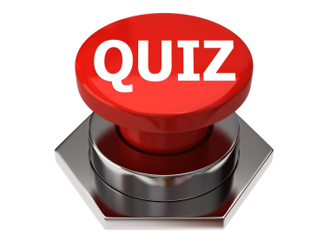
Name the Entrepreneur Product Brand

